Freight Cargo Inventory and Shipment Management System

  - Final Report

Muhammad Ahmad 30239993
Syed Essam Uddin Khawaja 30242943
Muhammad Zohaib Talat 30257908
CPSC 471 W26 - Group G-4

Abstract
This report presents the design, implementation, and evaluation of a Freight Cargo Inventory and Shipment Management System built for CPSC 471. The system models a global freight logistics network using a normalized PostgreSQL relational database hosted on Supabase. The schema consists of 15 relations (tables), 2 views, 2 stored functions, and 1 trigger, all derived from an Enhanced Entity-Relationship Diagram through the standard EERD-to-relational-model conversion algorithm. The application frontend is built with Next.js 15 (React 19, TypeScript, Tailwind CSS) and communicates with the database via parameterized SQL queries using the pg library. Authentication is handled by Supabase Auth with role resolution performed through SQL JOINs against the application's own user/role tables. The system supports two roles (Admin and Warehouse Staff), full CRUD operations on all entities, personalized dashboards scoped to assigned warehouses, inventory management via a stored function with negative-quantity guards, automatic audit logging via triggers, user registration approval workflows, and staff-to-admin promotion requests. The seed dataset models a realistic global freight network spanning 63 locations across 6 continents, 12 warehouses, 22 carriers, 55 shipments, and 77 containers. A live demo is deployed on Vercel at https://cpsc-471-inventory-manager.vercel.app.

Report Overview
This report is organized as follows:
- Section 1 - Introduction: outlines the freight logistics problem, project goals, and overall system structure.
- Section 2 - Project Design: explains the target users, key design decisions, and implementation trade-offs.
- Section 3 - Enhanced Entity-Relationship Diagram (EERD): presents the conceptual database design and the changes made from the earlier course deliverables.
- Section 4 - Relational Model Diagram (RM): presents the relational schema derived from the EERD, compares it with the earlier Progress Report 2 version, and explains the key conversion decisions.
- Section 5 - Implementation: describes the DBMS choice and representative SQL transactions used in the running system.
- Section 6 - Visual Interface Description: summarizes the major application pages and how users interact with the frontend.
- Section 7 - Supabase Dashboard and SQL Editor Screenshots: documents the hosted database environment and direct SQL verification workflow.
- Section 8 - User Guide: provides a practical walkthrough for accessing and using the application as an admin, staff member, or newly registered user.
- Section 9 - Summary of Changes from Initial Design: compares the original proposal and progress-report plans with the final implemented system.
- Section 10 - Conclusion: reflects on the completed system and how it meets the course objectives.

1. Introduction

1.1 Problem Description
Freight logistics companies manage enormous volumes of cargo moving between warehouses, ports, and distribution centers worldwide. Tracking which cargo items are stored at which warehouse, which containers hold which cargo, which shipments are in transit, and which carriers handle which routes requires a robust relational database at the center of the operation. Without a proper database system, this information is often tracked in spreadsheets, leading to data inconsistencies, lost inventory, and missed shipments.

1.2 Project Goal
Our goal was to design and implement a database-centric system that:
- Models the real-world entities and relationships of a freight cargo operation using a normalized relational schema
- Enforces data integrity through primary keys, foreign keys, NOT NULL constraints, and CHECK-like guards in stored functions
- Demonstrates advanced SQL features: views for reporting, stored functions for business logic, and triggers for automatic audit logging
- Provides a usable web interface for two distinct user roles (Admin and Staff) to interact with the data
- Includes realistic seed data for demonstration and evaluation

1.3 System Overview
The system we built is a full-stack web application with the following components:
- Database: PostgreSQL hosted on Supabase, with schema defined in ordered SQL files (sql/001 through sql/005)
- Backend: Next.js 15 App Router server components and API routes that execute direct parameterized SQL against the database via the pg library
- Frontend: React 19 with Tailwind CSS, featuring a role-filtered sidebar, dark/light mode toggle, and mobile-responsive layout
- Authentication: Supabase Auth for session management (JWT cookies), with role resolution via SQL JOINs against our own users, admins, and warehouse_staff tables

2. Project Design

2.1 Users of the System
The system serves three categories of users:
Administrators (Admin role)
- Have full access to all entity management pages (warehouses, carriers, routes, locations, shipments, containers, cargo items, inventory)
- Can create, read, update, and delete records in all tables
- Manage other users: create new accounts, approve pending registrations, approve or reject staff-to-admin promotion requests, assign users to warehouses, demote admins back to staff
- Access the Reports page with aggregated views
- See a personalized dashboard showing KPIs, recent shipments, and warehouse capacity for their assigned warehouses only
- Each admin can manage multiple warehouses (many-to-many through the manages table)
Warehouse Staff (Staff role)
- Have access to a subset of entity pages: Dashboard, Inventory, Shipments, Containers, and Cargo Items
- Can view and manage inventory records for their assigned warehouse
- Can create new cargo items and adjust inventory quantities
- Can submit a request for admin promotion (with a reason, max 1000 characters)
- See a personalized dashboard scoped to their single assigned warehouse
- Do not have access to master data management (carriers, routes, locations), user management, or reporting
Pending Users
- Users who self-register through the /register page start with account_status = 'pending_registration'
- They can log in, but are immediately redirected to the /pending page
- They cannot access any entity pages until an admin approves their registration

2.2 Design Decisions and Trade-offs
Email-based linking (no auth_user_id column): We chose to link Supabase Auth users to our public.users table by email rather than storing a Supabase auth_user_id column. This avoids coupling our schema to Supabase internals and means all user management can happen through SQL without needing the Supabase dashboard.
Disjoint specialization tables retained: The EERD specifies User ISA Admin and User ISA WarehouseStaff as a disjoint total specialization. We kept separate admins and warehouse_staff tables rather than collapsing them into a single table with a role column. This was required by the earlier EERD design and also makes role determination a simple LEFT JOIN operation.
Direct SQL (no ORM): All application data access uses parameterized SQL queries via the pg library. We chose this deliberately to maximize SQL visibility and demonstrate database concepts directly. Supabase's ORM connection snippet is used only during setup to obtain DATABASE_URL; the running application itself does not use an ORM.
Gapless user IDs: We use manual MAX(user_id) + 1 inserts for new users instead of relying solely on BIGSERIAL auto-increment. This avoids gaps in user IDs that would result from failed or rolled-back inserts, which is important for a demonstration system where IDs are visible in the UI.
Server actions with redirect for error handling: Next.js server actions cannot return values to server components directly. We use redirect('/path?error=message') and redirect('/path?success=message') patterns to communicate results back to the user.

3. Enhanced Entity-Relationship Diagram (EERD)

3.1 Original EERD (Progress Report 1)
The original EERD was designed during Progress Report 1. It contained the following entities and relationships:
Entities: User, Admin (specialization), Warehouse Staff (specialization), Warehouse, Location, CargoItem, InventoryRecord (weak entity), Carrier, Route, Shipment, Container
Relationships: ISA (disjoint), MANAGES, WORKS_AT, CREATES, UPDATES, LOCATED_AT, STORES, TRACKS, HANDLED_BY, USES, DELIVERED TO/FROM, ASSIGNED, CONTAINS

3.2 Final EERD (Changes from Original)
The final EERD is in docs/RM&EERD/EERD.drawio. The following changes were made during implementation:
- Added `account_status` attribute to User - needed for the registration approval workflow. Values: active, pending_registration, rejected, disabled.
- Added `role_id` attribute to User - explicit role indicator (1=Admin, 2=Staff) used alongside the specialization tables for quick lookups.
- Added AdminAccessRequest entity - a new entity for the staff-to-admin promotion workflow, with attributes: request_id (PK), user_id (FK), reason, status, requested_at, resolved_at, resolved_by_user_id (FK). Connected to User via a REQUESTS relationship.
- Added AuditLog entity - for tracking data changes, with attributes: id (PK), user_id (FK, nullable), action_type, entity_type, entity_id, payload (JSONB), created_at. Connected to User via a dashed optional link (ON DELETE SET NULL).
- Added `warehouse_id` attribute to WarehouseStaff - a direct foreign key to Warehouse for simple staff-warehouse assignment, in addition to the WORKS_AT relationship.
- Corrected InventoryRecord notation - shown with a double border to properly indicate it is a weak entity, uniquely identified by the composite key (cargo_id, warehouse_id).
All original entities and relationships from the Prog1 EERD were preserved. No entities or relationships were removed.
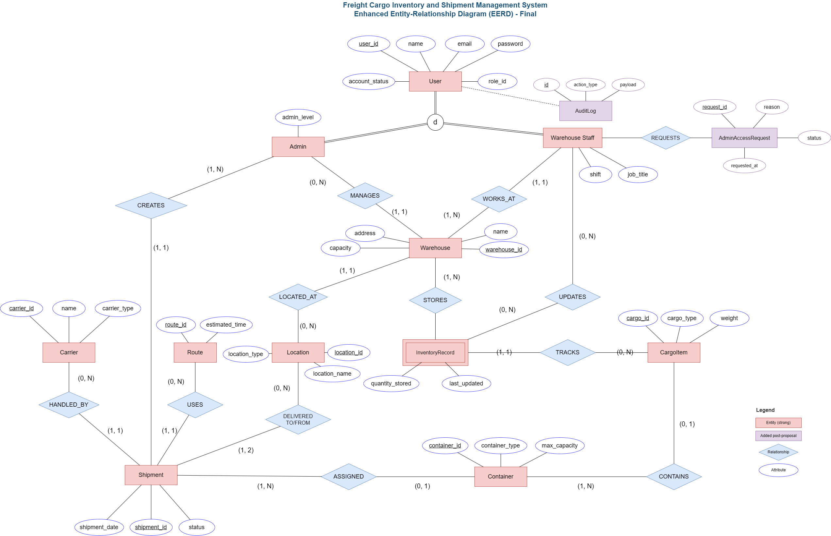

3.3 Entity Summary Table
Entity | Type | PK | Key Attributes
User | Strong | user_id | name, email, password, role_id, account_status
Admin | Specialization of User | user_id (FK) | admin_level
WarehouseStaff | Specialization of User | user_id (FK) | job_title, shift, warehouse_id (FK)
Warehouse | Strong | warehouse_id | name, address, capacity, location_id (FK)
Location | Strong | location_id | location_name, location_type
CargoItem | Strong | cargo_id | cargo_type, weight
InventoryRecord | Weak (on Warehouse + CargoItem) | (cargo_id, warehouse_id) | quantity_stored, last_updated
Carrier | Strong | carrier_id | name, carrier_type
Route | Strong | route_id | estimated_time
Shipment | Strong | shipment_id | shipment_date, status, carrier_id, route_id, origin_loc_id, destination_loc_id
Container | Strong | container_id | container_type, max_capacity, shipment_id (FK, nullable)
ContainerCargo | Associative | (cargo_id, container_id) | (none; pure junction table)
AuditLog | Strong (added) | id | user_id, action_type, entity_type, entity_id, payload, created_at
AdminAccessRequest | Strong (added) | request_id | user_id, reason, status, requested_at, resolved_at, resolved_by_user_id

3.4 Relationship Summary Table
Relationship | Entity A | Entity B | Cardinality A | Cardinality B
ISA (disjoint) | User | Admin, WarehouseStaff | 1 | 1
MANAGES | Admin | Warehouse | (0, N) | (1, 1)
WORKS_AT | WarehouseStaff | Warehouse | (1, 1) | (1, N)
CREATES | Admin | Shipment | (1, N) | (1, 1)
UPDATES | WarehouseStaff | InventoryRecord | (0, N) | (0, N)
LOCATED_AT | Warehouse | Location | (1, 1) | (0, N)
STORES | Warehouse | InventoryRecord | (1, N) | --
TRACKS | InventoryRecord | CargoItem | (1, 1) | (0, N)
HANDLED_BY | Carrier | Shipment | (0, N) | (1, 1)
USES | Route | Shipment | (0, N) | (1, 1)
DELIVERED TO/FROM | Location | Shipment | (0, N) | (1, 2)
ASSIGNED | Shipment | Container | (1, N) | (0, 1)
CONTAINS | Container | CargoItem | (1, N) | (0, 1)
REQUESTS | WarehouseStaff | AdminAccessRequest | (0, N) | (1, 1)

4. Relational Model Diagram (RM)

4.1 Original Relational Model (Progress Report 2)
The original relational model was designed during Progress Report 2. It contained the following 13 relations derived from the original EERD:
Relations: User, Admin, WarehouseStaff, Manages, Warehouse, Location, CargoItem, InventoryRecord, Carrier, Route, Shipment, Container, ContainerCargo
This version already included role_id in User and warehouse_id in WarehouseStaff, but it did not yet include the account lifecycle or approval/audit workflow relations that were added later during implementation.

4.2 Final Relational Model (Changes from Original)
The final relational model is in docs/RM&EERD/RelationalModel.drawio. The following changes were made during implementation:
- Added `account_status` to User - needed to represent registration and account lifecycle states such as pending_registration, active, rejected, and disabled.
- Added AuditLog relation - a new relation for persistent change tracking with columns: id (PK), user_id (FK nullable), action_type, entity_type, entity_id, payload, created_at.
- Added AdminAccessRequest relation - a new relation supporting the staff-to-admin promotion workflow, with columns: request_id (PK), user_id (FK), reason, status, requested_at, resolved_at, resolved_by_user_id (FK nullable).
- Retained all 13 original relations from Progress Report 2 - the existing core freight, warehouse, shipment, and inventory relations were preserved and extended rather than replaced.
The final RM therefore contains 15 relations in total.
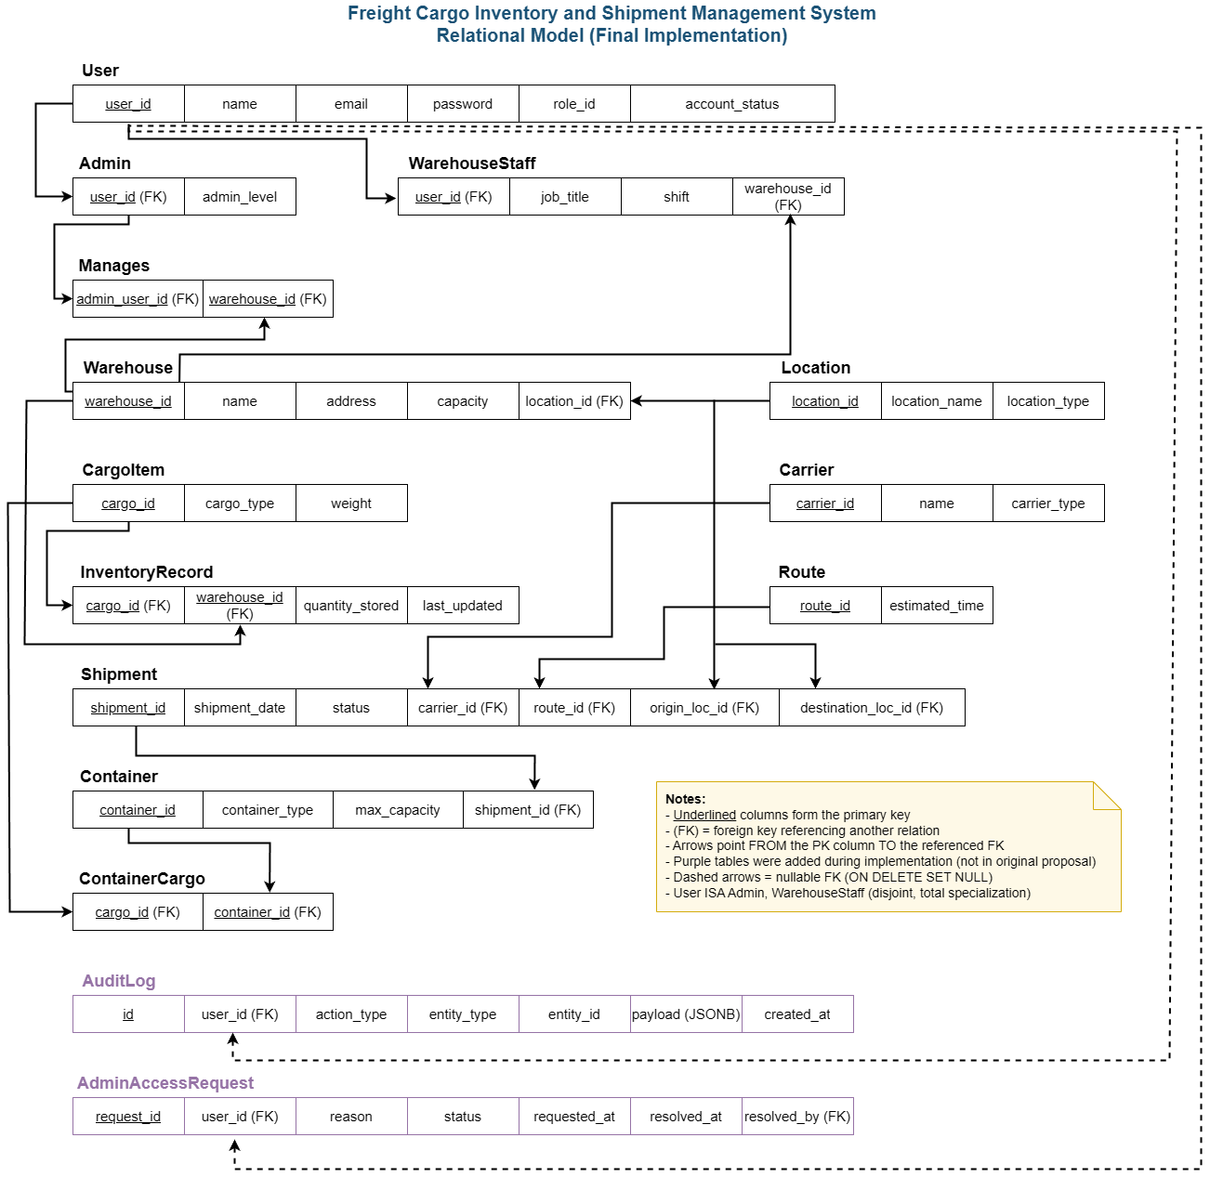

4.3 Relation Summary Table
Relation | Type | Primary Key | Key Columns
User | Strong | user_id | name, email, password, role_id, account_status
Admin | Specialization of User | user_id (FK) | admin_level
WarehouseStaff | Specialization of User | user_id (FK) | job_title, shift, warehouse_id (FK)
Manages | Associative | (admin_user_id, warehouse_id) | admin_user_id (FK), warehouse_id (FK)
Warehouse | Strong | warehouse_id | name, address, capacity, location_id (FK)
Location | Strong | location_id | location_name, location_type
CargoItem | Strong | cargo_id | cargo_type, weight
InventoryRecord | Weak (on Warehouse + CargoItem) | (cargo_id, warehouse_id) | quantity_stored, last_updated
Carrier | Strong | carrier_id | name, carrier_type
Route | Strong | route_id | estimated_time
Shipment | Strong | shipment_id | shipment_date, status, carrier_id, route_id, origin_loc_id, destination_loc_id
Container | Strong | container_id | container_type, max_capacity, shipment_id (FK, nullable)
ContainerCargo | Associative | (cargo_id, container_id) | cargo_id (FK), container_id (FK)
AuditLog | Strong (added) | id | user_id, action_type, entity_type, entity_id, payload, created_at
AdminAccessRequest | Strong (added) | request_id | user_id, reason, status, requested_at, resolved_at, resolved_by_user_id

4.4 Conversion Decisions
The following decisions were made during the EERD-to-RM conversion:
Disjoint specialization (ISA): We used the "separate tables" approach for the User ISA hierarchy. The admins table has user_id as both its PK and an FK referencing users.user_id. Same for warehouse_staff. This preserves the disjoint constraint at the application level (a user is inserted into exactly one specialization table) and allows each specialization to have its own attributes without NULL columns.
Weak entity (InventoryRecord): InventoryRecord is identified by the composite key (cargo_id, warehouse_id). Both columns are foreign keys referencing their respective parent tables with ON DELETE RESTRICT, preventing deletion of a cargo item or warehouse that still has inventory records.
M:N relationship (CONTAINS): The many-to-many relationship between Container and CargoItem was converted to the container_cargo junction table with a composite PK (cargo_id, container_id).
M:N relationship (MANAGES): The many-to-many relationship between Admin and Warehouse was converted to the manages table with a composite PK (admin_user_id, warehouse_id).
1:N relationships: All 1:N relationships were implemented by placing the FK on the "many" side. For example, warehouses.location_id references locations.location_id, and shipments.carrier_id references carriers.carrier_id.
Dual FK to same table (DELIVERED TO/FROM): The Shipment entity has two FK columns referencing Location: origin_loc_id and destination_loc_id. Both use ON DELETE RESTRICT.
Optional participation (ASSIGNED): The Container entity has a nullable shipment_id FK. Containers can exist without being assigned to a shipment (NULL means "in yard, unassigned").

5. Implementation

5.1 DBMS Selection
We selected PostgreSQL as our DBMS, hosted on Supabase. The reasons for this choice:
- PostgreSQL supports all required features: stored functions (PL/pgSQL), triggers, views, JSONB columns, and CHECK-like constraints via RAISE EXCEPTION in functions
- Supabase provides a free-tier hosted PostgreSQL instance with a web-based SQL editor, making it easy for people to inspect the database directly
- Supabase also provides built-in authentication (Supabase Auth) that integrates well with Next.js via the @supabase/ssr package
- The pg Node.js library provides direct SQL access with parameterized queries, which is ideal for a course focused on SQL rather than ORMs

5.2 SQL Statements for Key Transactions
Below are the SQL statements for the primary transactions implemented in the system.
Transaction 1: User Registration
-- Step 1: Create Supabase Auth account (via supabase.auth.signUp in application code)
-- Step 2: Insert application user
INSERT INTO users (user_id, name, email, password, role_id, account_status)
VALUES ((SELECT COALESCE(MAX(user_id), 0) + 1 FROM users), $1, $2, 'dev-only', 2, 'pending_registration');
-- Step 3: Insert warehouse_staff specialization
INSERT INTO warehouse_staff (user_id, job_title, shift)
VALUES ($1, 'New User', 'Day');
Transaction 2: Admin Approves User Registration
UPDATE users SET account_status = 'active' WHERE user_id = $1;
Transaction 3: Create Shipment
INSERT INTO shipments (shipment_id, shipment_date, status, carrier_id, route_id, origin_loc_id, destination_loc_id)
VALUES ((SELECT COALESCE(MAX(shipment_id), 0) + 1 FROM shipments), $1, $2, $3, $4, $5, $6);
Transaction 4: Assign Container to Shipment
UPDATE containers SET shipment_id = $1 WHERE container_id = $2;
Transaction 5: Adjust Inventory (via stored function)
SELECT fn_update_inventory($1, $2, $3, $4);
-- Parameters: cargo_id, warehouse_id, delta_quantity, staff_user_id
-- Function performs UPSERT with ON CONFLICT, checks for negative quantity,
-- and logs to audit_logs via fn_audit_log()
Transaction 6: Create Warehouse
INSERT INTO warehouses (warehouse_id, name, address, capacity, location_id)
VALUES ((SELECT COALESCE(MAX(warehouse_id), 0) + 1 FROM warehouses), $1, $2, $3, $4);
Transaction 7: Delete Entity (with FK check)
-- Example: Delete carrier (checks for referencing shipments first)
-- Application code first checks:
SELECT COUNT(*) FROM shipments WHERE carrier_id = $1;
-- If count > 0, deletion is blocked with an error message
-- If count = 0:
DELETE FROM carriers WHERE carrier_id = $1;
Transaction 8: Promote Staff to Admin
-- Step 1: Insert into admins specialization
INSERT INTO admins (user_id, admin_level) VALUES ($1, 1);
-- Step 2: Remove from warehouse_staff specialization
DELETE FROM warehouse_staff WHERE user_id = $1;
-- Step 3: Update role_id
UPDATE users SET role_id = 1 WHERE user_id = $1;
-- Step 4: Mark request as approved
UPDATE admin_access_requests SET status = 'approved', resolved_at = NOW(),
resolved_by_user_id = $2 WHERE request_id = $3;
Transaction 9: Demote Admin to Staff
-- Step 1: Remove from admins
DELETE FROM admins WHERE user_id = $1;
-- Step 2: Remove all manages entries
DELETE FROM manages WHERE admin_user_id = $1;
-- Step 3: Insert into warehouse_staff
INSERT INTO warehouse_staff (user_id, job_title, shift) VALUES ($1, 'Staff', 'Day');
-- Step 4: Update role_id
UPDATE users SET role_id = 2 WHERE user_id = $1;
Transaction 10: Get Current User Role (getCurrentUser)
SELECT u.user_id, u.name, u.account_status,
CASE
WHEN a.user_id IS NOT NULL THEN 'ADMIN'
WHEN ws.user_id IS NOT NULL THEN 'STAFF'
ELSE 'UNKNOWN'
END AS role
FROM users u
LEFT JOIN admins a ON a.user_id = u.user_id
LEFT JOIN warehouse_staff ws ON ws.user_id = u.user_id
WHERE u.email = $1
LIMIT 1;

Transaction 11: Dashboard KPIs (personalized)
-- Shipment counts by status for user's warehouses
SELECT
COUNT(*) FILTER (WHERE s.status = 'IN_TRANSIT') AS in_transit,
COUNT(*) FILTER (WHERE s.status = 'PENDING') AS pending,
COUNT(*) FILTER (WHERE s.status = 'DELIVERED') AS delivered
FROM shipments s
WHERE s.origin_loc_id IN (SELECT location_id FROM warehouses WHERE warehouse_id = ANY($1))
OR s.destination_loc_id IN (SELECT location_id FROM warehouses WHERE warehouse_id = ANY($1));
Transaction 12: Reports - View Queries
-- Warehouse inventory summary
SELECT * FROM view_warehouse_inventory ORDER BY warehouse_name;
-- Shipment summary
SELECT * FROM view_shipment_summary ORDER BY shipment_date DESC LIMIT 500;

6. Visual Interface Description
The application features a modern, dark-mode-first design built with Tailwind CSS. The interface is organized around a persistent sidebar navigation and a top bar showing the current user's email and a sign-out button.

6.1 Sign In Page
The login page presents a clean form with email and password fields. Authentication is handled by Supabase Auth. On successful login, the user is redirected to the dashboard (if active) or the pending page (if registration is pending).
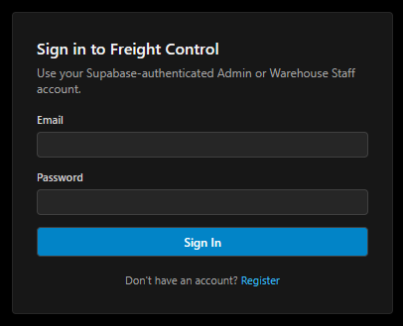

6.2 Registration Page
New users can self-register by providing their name, email, and password. The system creates both a Supabase Auth account and an application user with pending_registration status. The user is then shown a confirmation and redirected to the pending page.
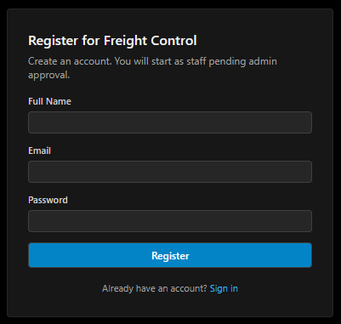

6.3 Pending Page
After registration, users who have not yet been approved by an admin are redirected to the pending page. This screen clearly informs them that their account is awaiting approval and that they cannot access the main system until their account_status is changed to active.
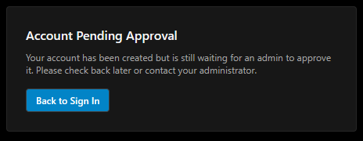

6.4 Admin Dashboard and Sidebar View
The admin dashboard shows personalized KPIs scoped to the admin's assigned warehouses: in-transit, pending, and delivered shipment counts; top carriers by volume; recent shipments; and warehouse capacity utilization bars. The sidebar shows all navigation sections: Operations, Master Data, Analytics, and Administration.
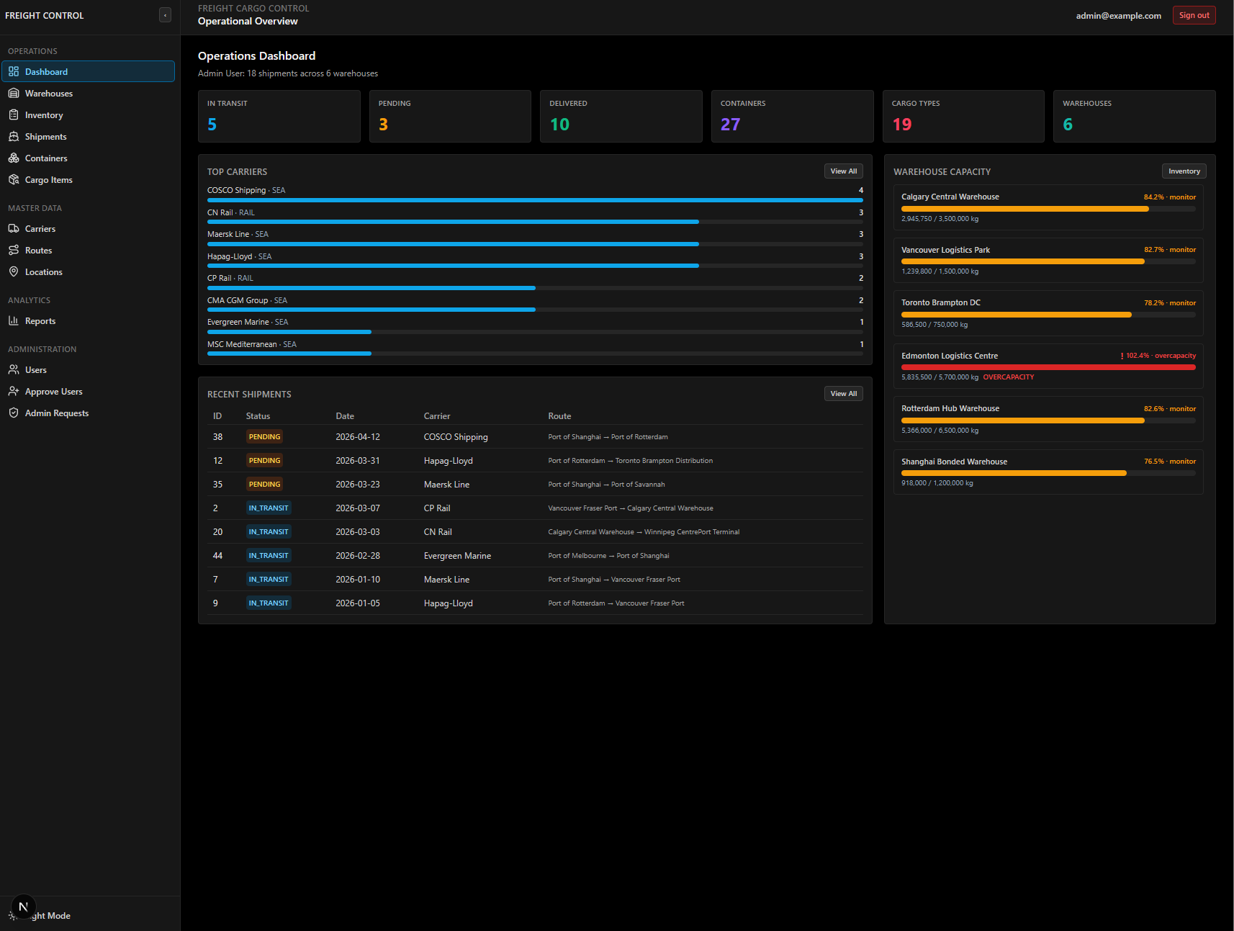

6.5 Staff Dashboard and Sidebar View
The staff dashboard shows the same KPI layout but scoped to the staff member's single assigned warehouse. The sidebar shows a reduced set of navigation items: Operations (minus Warehouses) and a Staff section with "Request Admin."
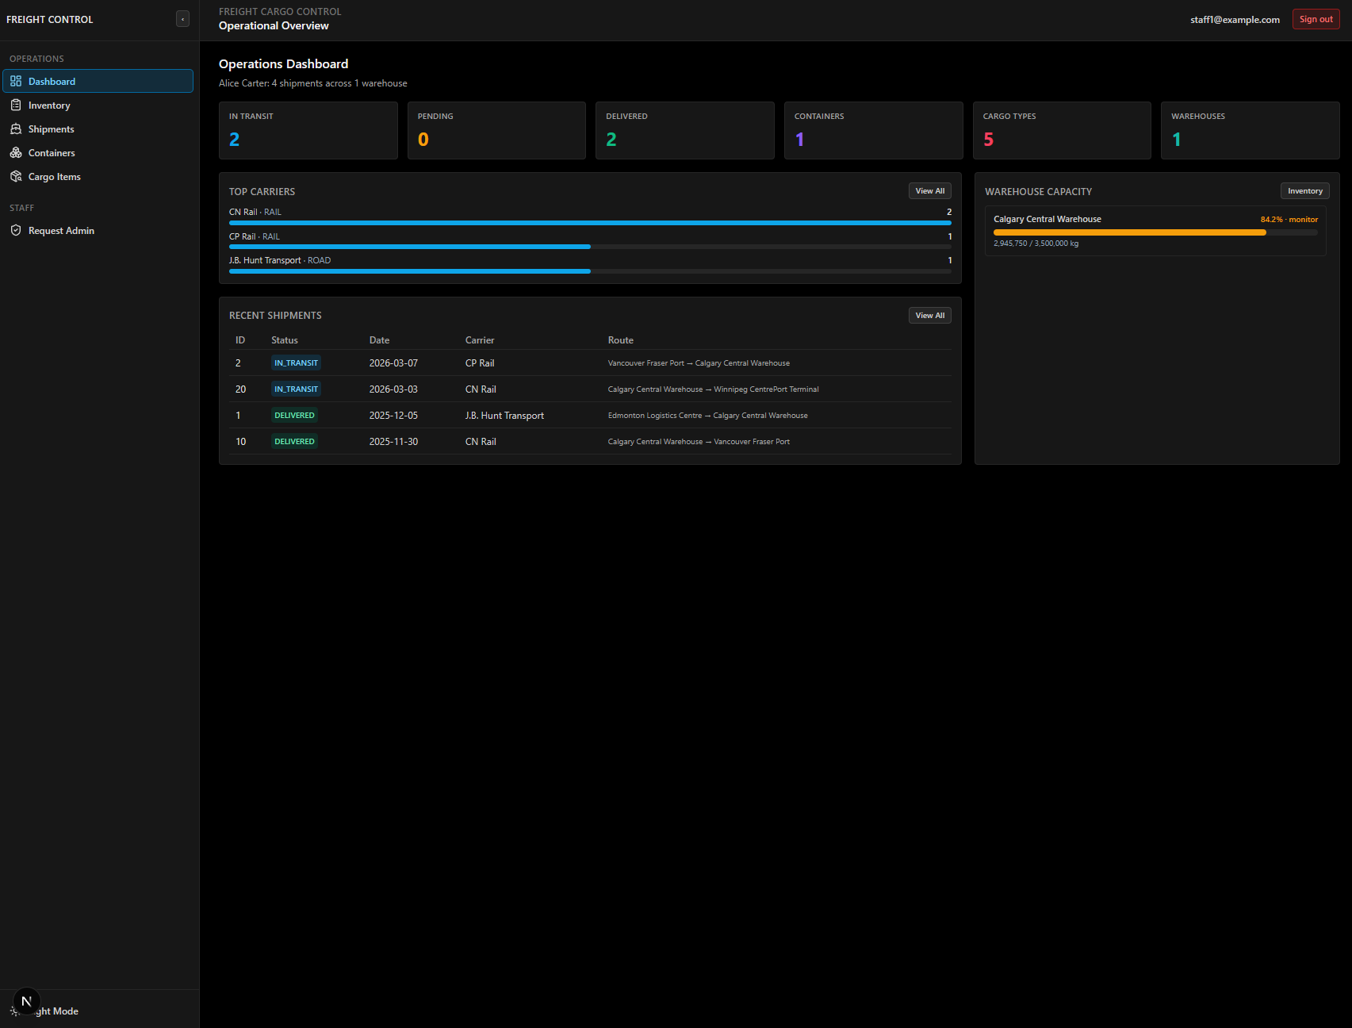

6.6 Warehouses Page
Displays all warehouses in a table with columns for ID, name, address, capacity, and location. Admins can create new warehouses, edit existing ones, and delete warehouses (with FK constraint checking). The create/edit forms allow selecting a location from a dropdown populated via SQL.
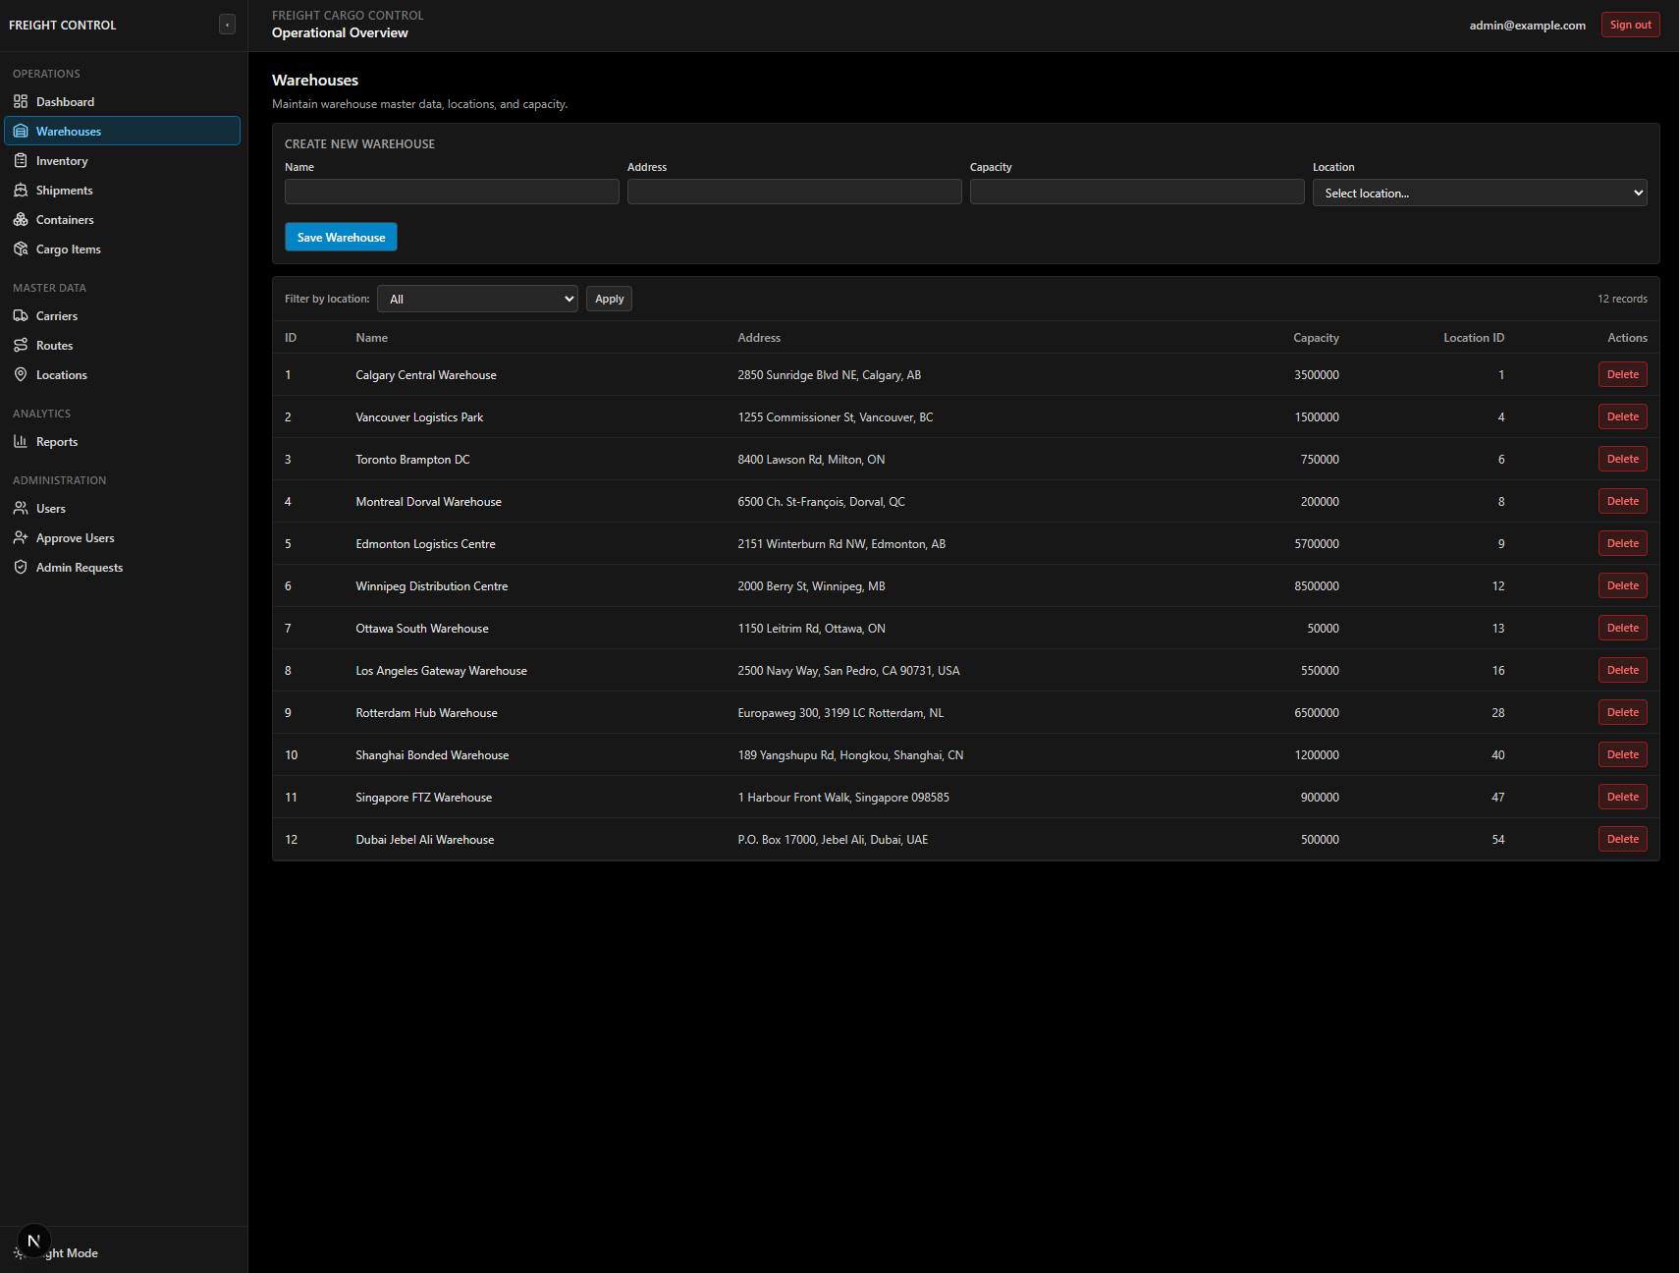

6.7 Inventory Page
Shows inventory records with cargo ID, warehouse ID, quantity stored, and last updated timestamp. Users can adjust quantities (which calls fn_update_inventory() on the server), create new inventory records, and delete existing ones.
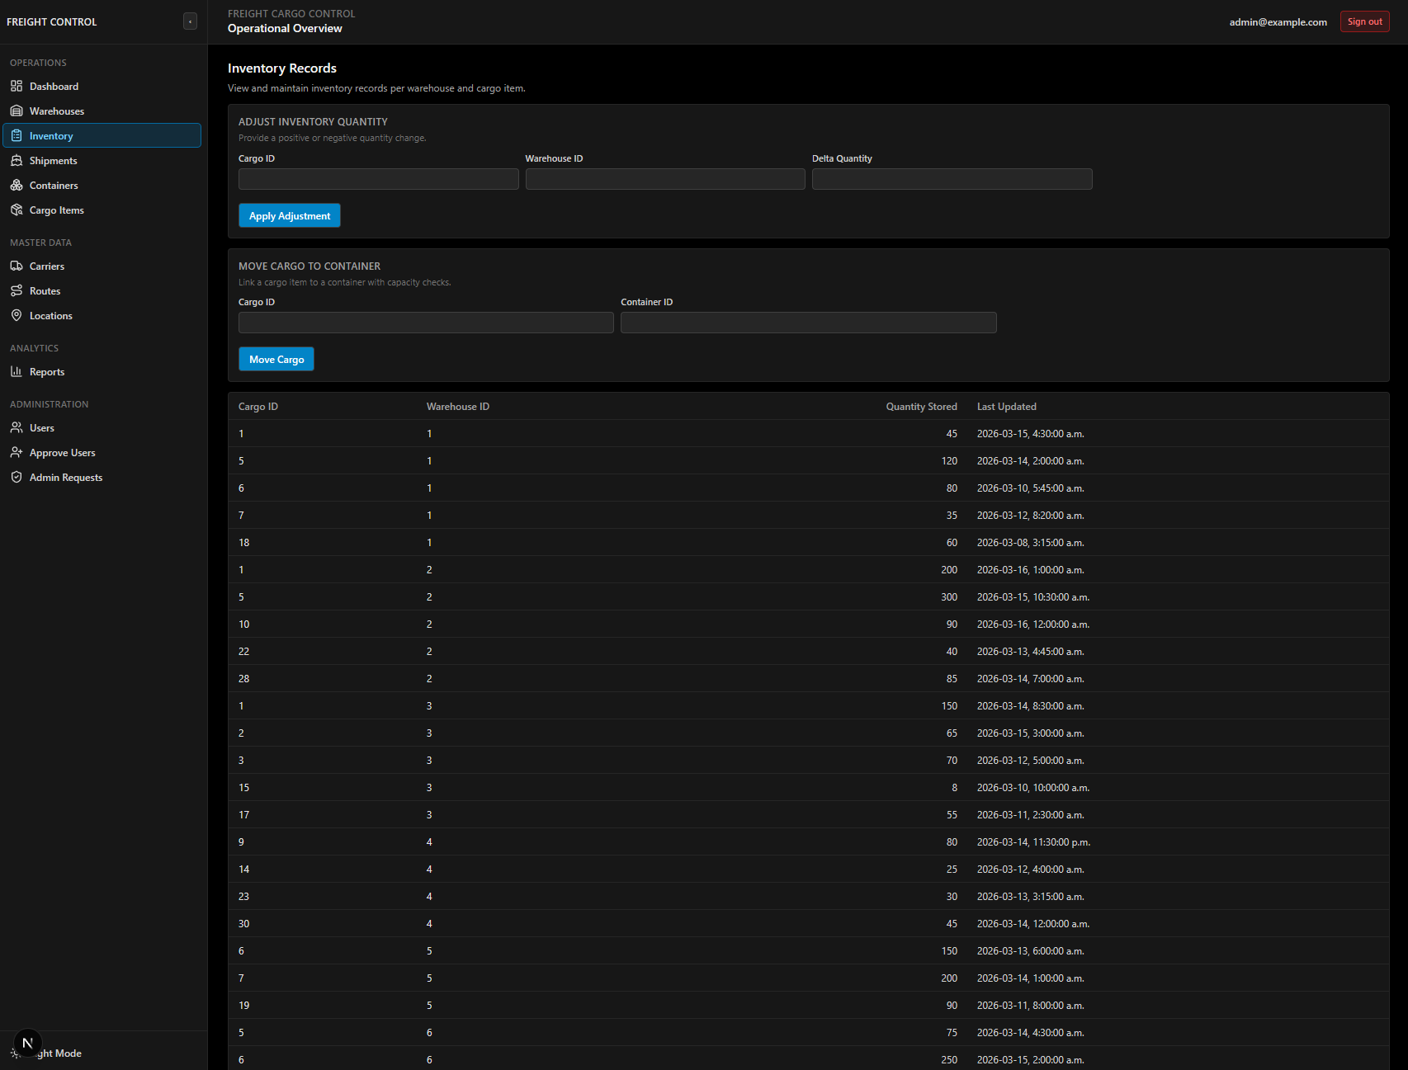

6.8 Shipments Page
Lists all shipments with ID, date, status, carrier, route, origin, and destination. Admins can create new shipments by selecting carriers, routes, and locations from dropdowns. Status updates (PENDING, IN_TRANSIT, DELIVERED, CANCELLED) are done through edit forms.
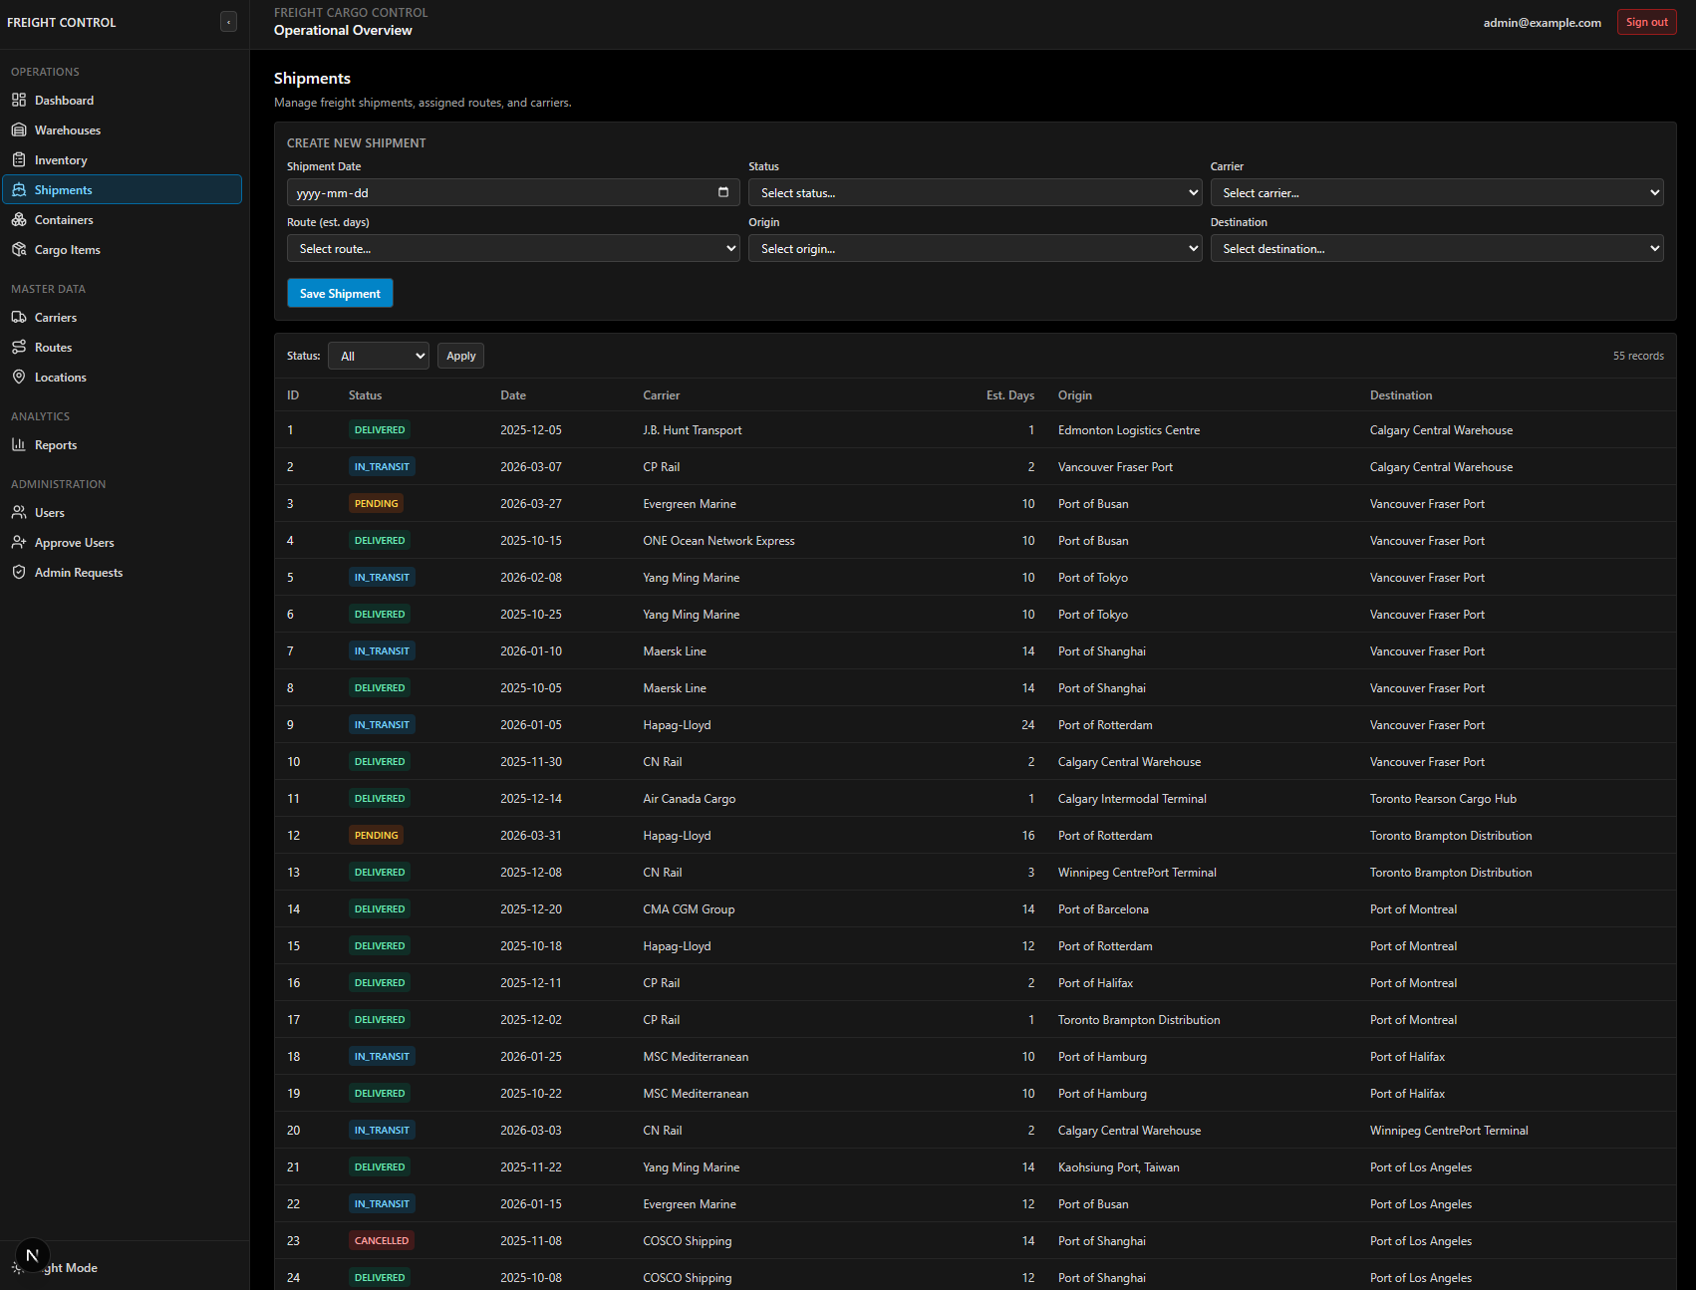

6.9 Containers Page
Displays all containers with their type, max capacity, and assigned shipment. Admins can create new containers, assign/unassign them to shipments, and manage container-cargo links.
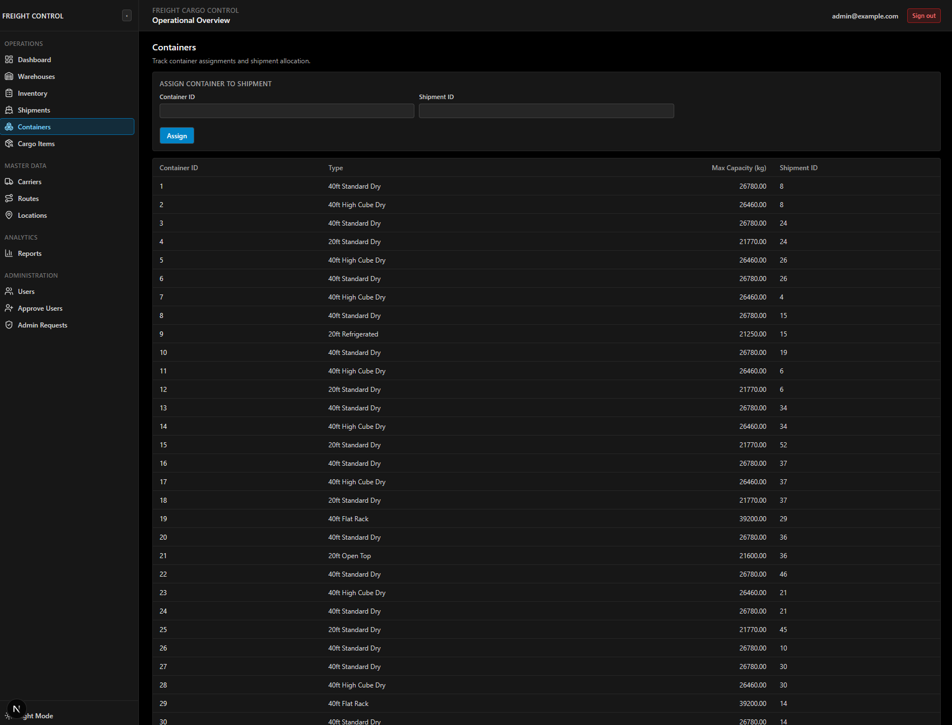

6.10 Cargo Items Page
Lists all cargo item types with their ID, type name, and unit weight. Admins and staff can create new cargo items and manage existing ones.
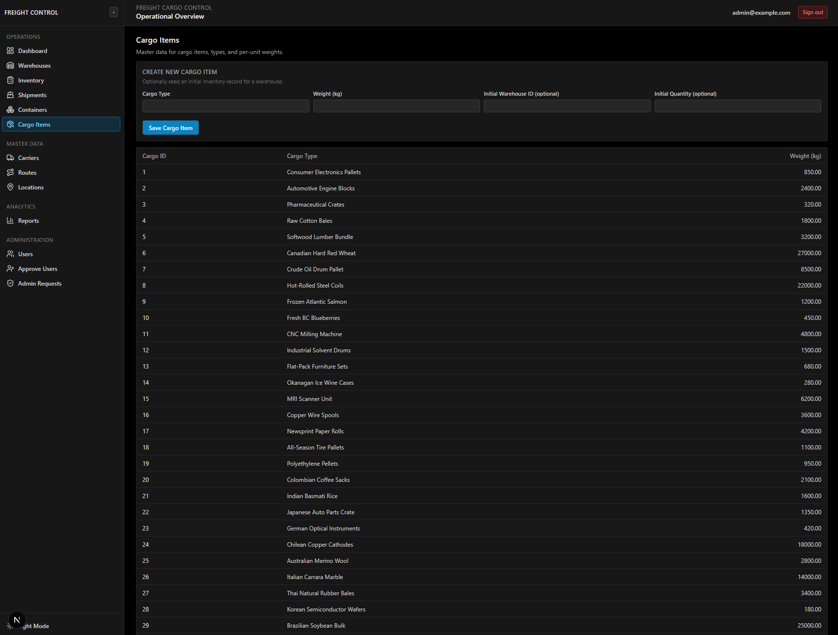

6.11 Carriers Page (Admin Only)
Displays all carriers with ID, name, and type (AIR, SEA, RAIL, ROAD). Admins can create, edit, and delete carriers. Deletion is blocked if the carrier has associated shipments.
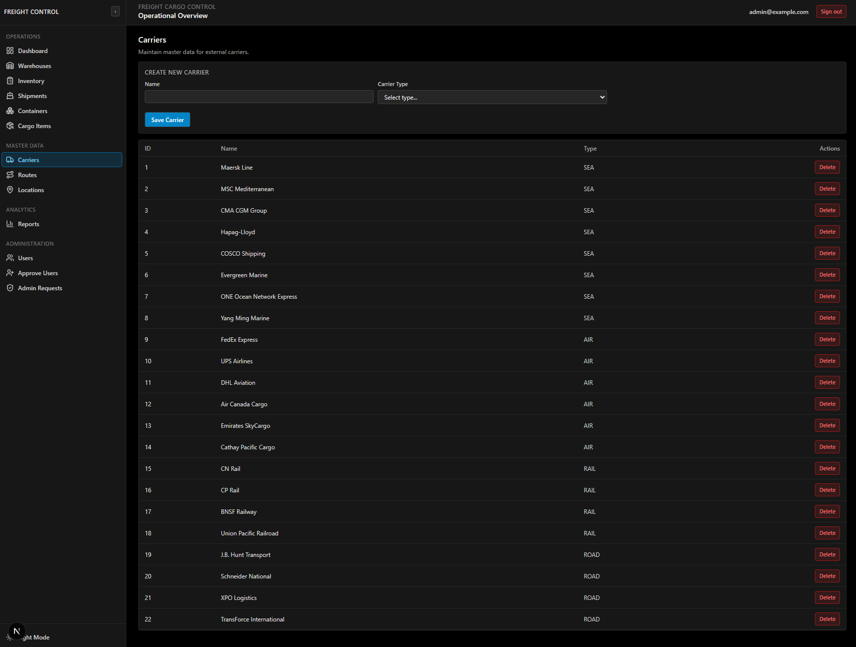

6.12 Routes Page (Admin Only)
Shows all routes with their ID and estimated transit time (in days). Admins can create new routes and manage existing ones.
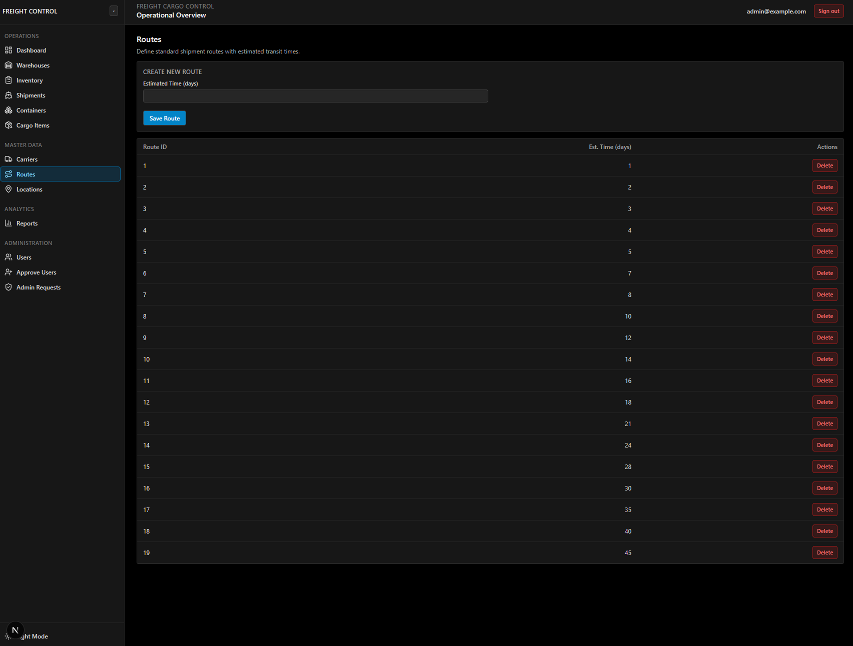

6.13 Locations Page (Admin Only)
Lists all 63 locations with their ID, name, and type (WAREHOUSE, PORT, RAIL_TERMINAL, DISTRIBUTION, AIRPORT). Admins can create new locations and manage existing ones.
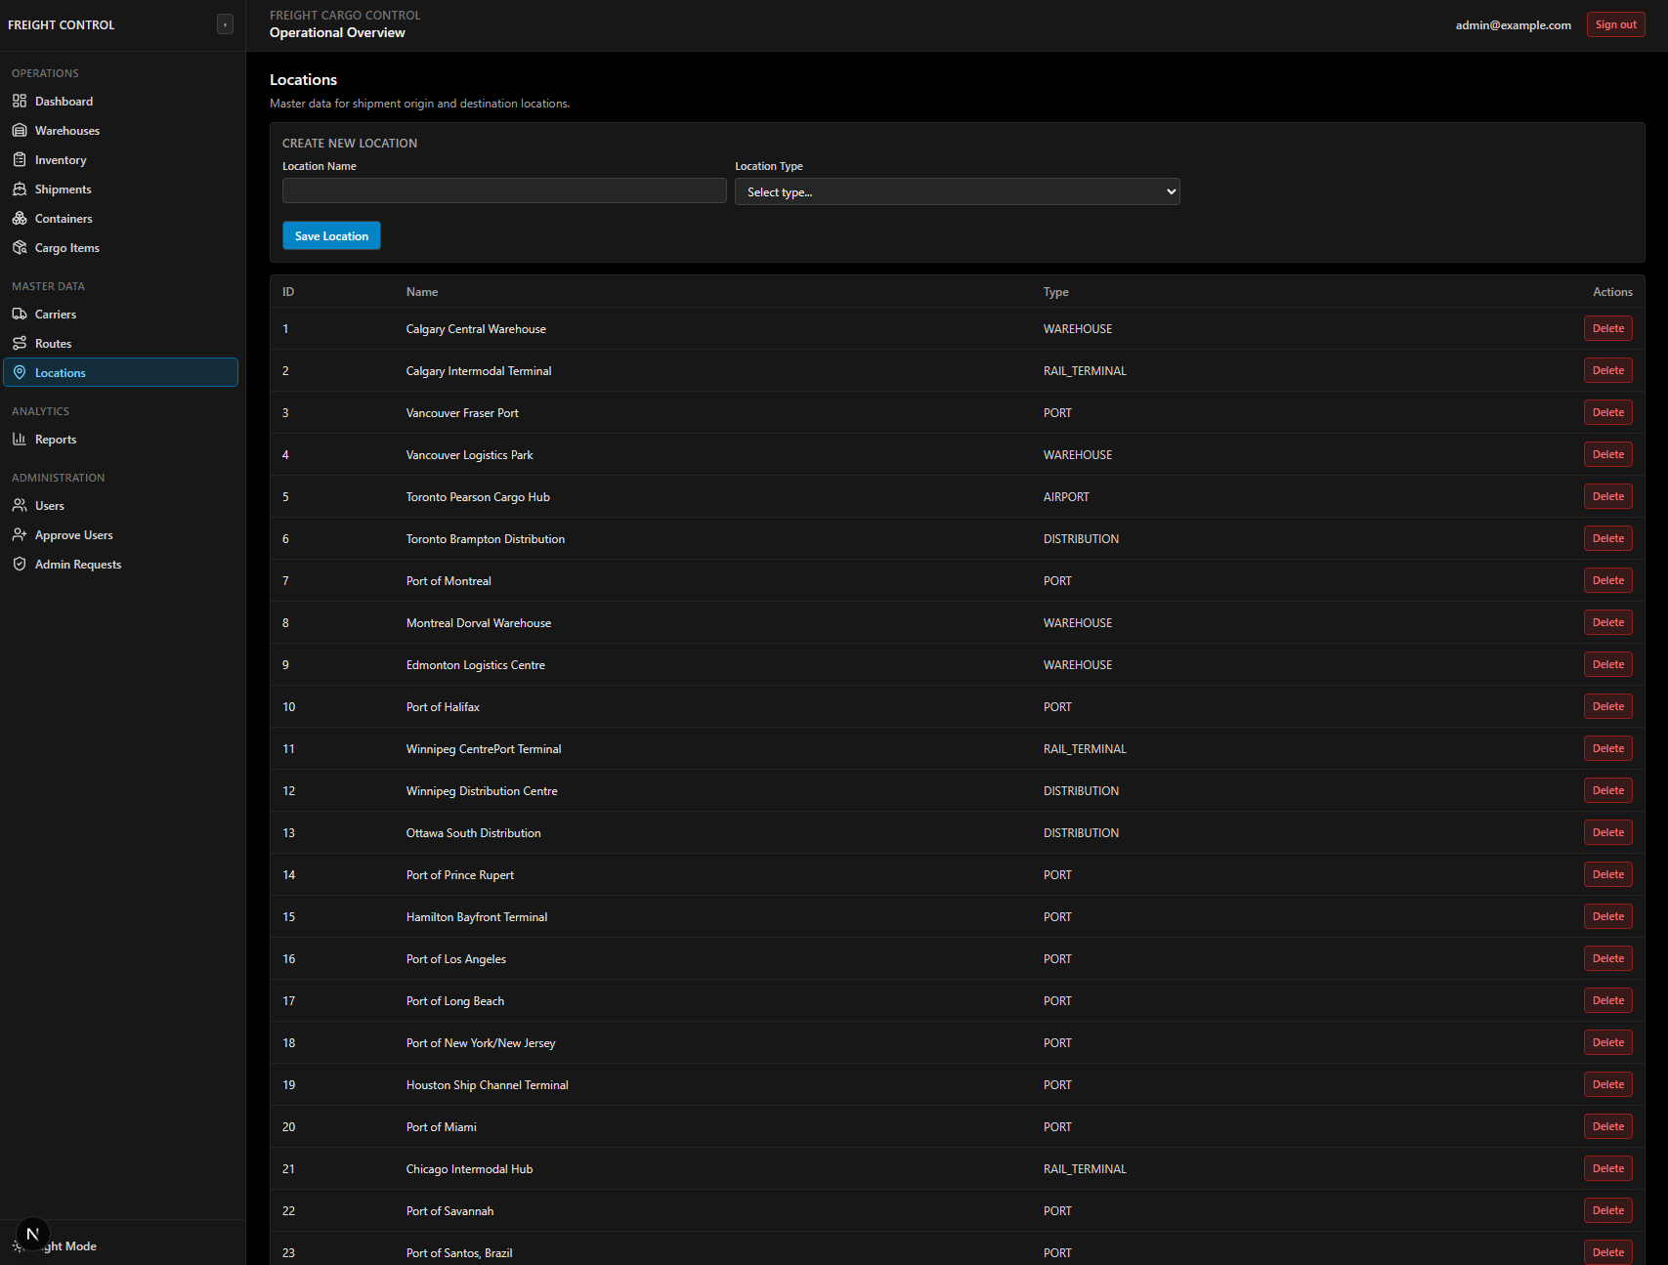

6.14 Reports Page (Admin Only)
Displays two summary tables generated from database views:
- Warehouse Inventory Summary (from view_warehouse_inventory): warehouse name, total units, total weight
- Shipment Summary (from view_shipment_summary): shipment ID, status, date, carrier, container count, cargo item count
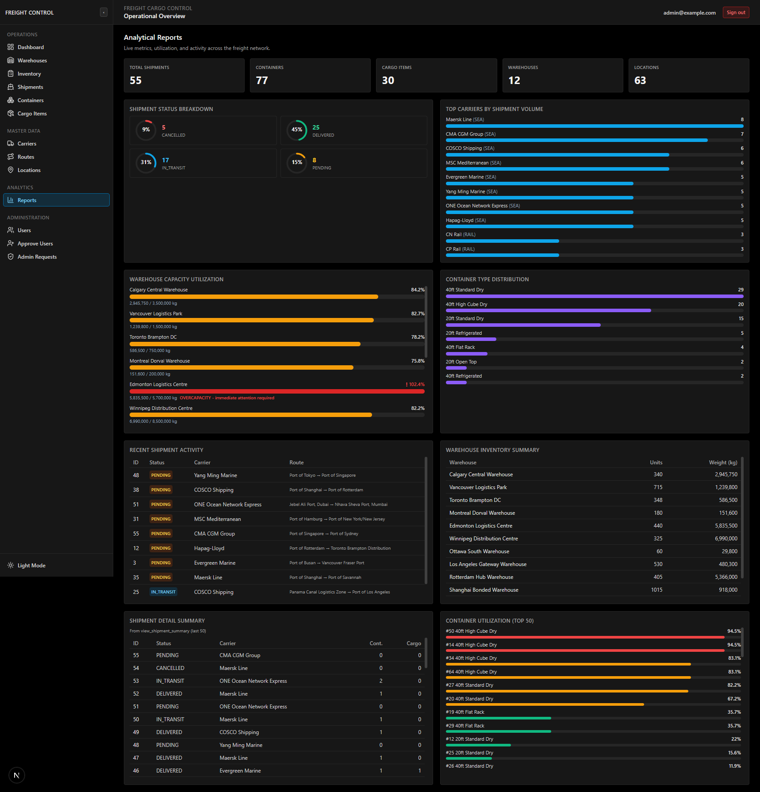

6.15 Users Page (Admin Only)
Contains four management panels:
- Create New User - form with name, email, and role selection. Creates both Supabase Auth and DB user.
- Update User - load by ID, edit name/email, option to promote to admin.
- Assign User to Warehouse - works for both admin (inserts into manages) and staff (updates warehouse_staff.warehouse_id).
- Demote Admin to Staff - requires the DEMOTION_KEY environment variable. Cannot self-demote.
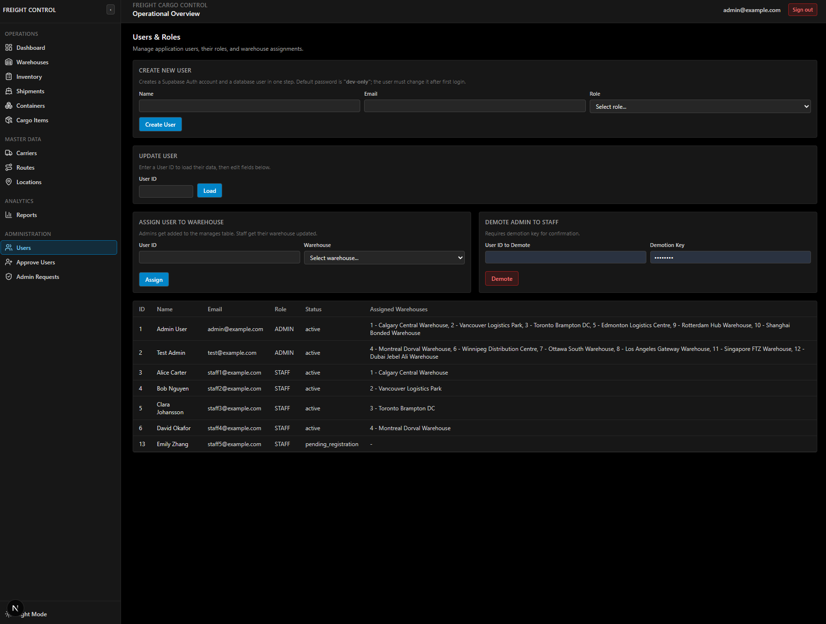

6.16 Approve Users Page (Admin Only)
Lists all users with account_status = 'pending_registration'. Admins can approve (sets status to active) or reject (sets status to rejected) each pending user.
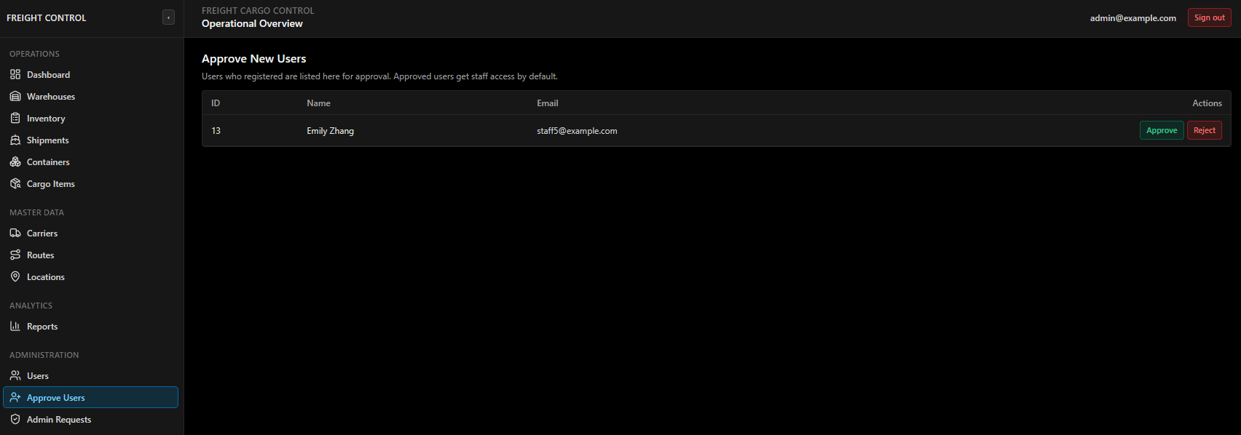

6.17 Admin Requests Page (Admin Only)
Lists all pending admin access requests. Shows the requesting user's name, email, and reason. Admins can approve (triggers the promotion SQL transaction) or reject (marks the request as rejected).
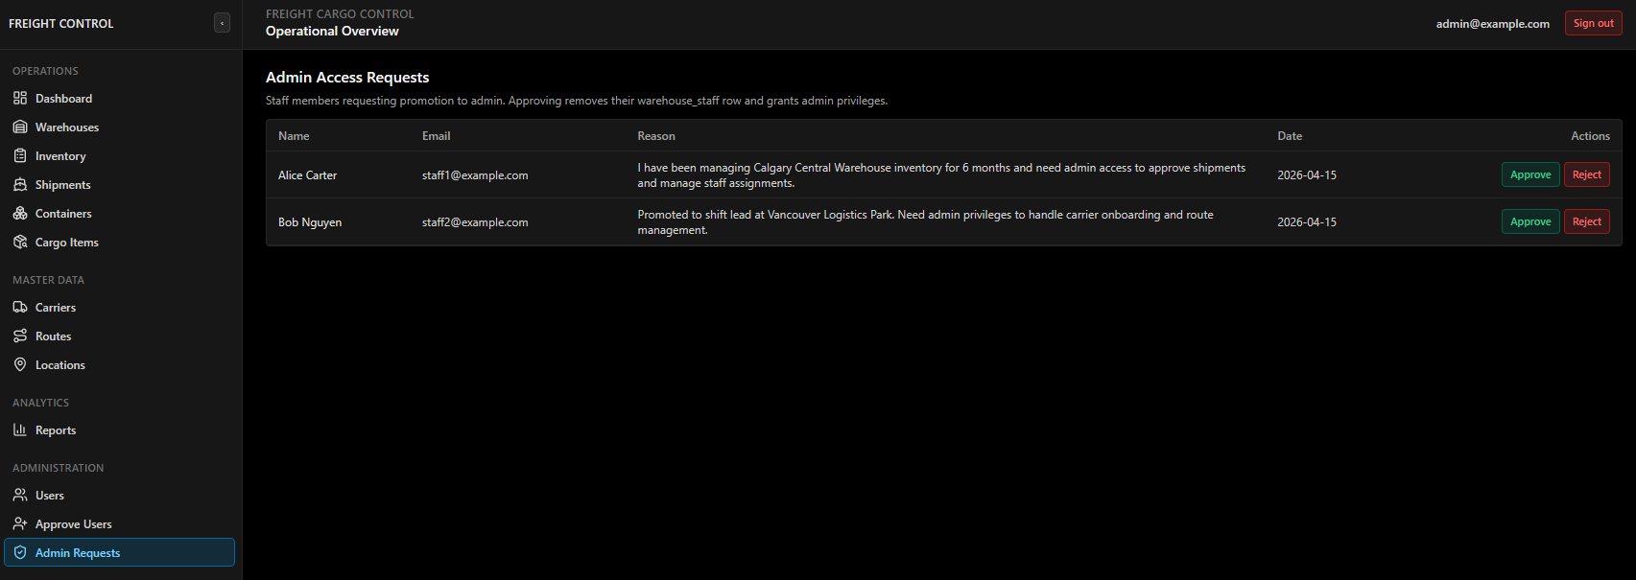

6.18 Light Mode Showcase
The application supports both dark mode (default) and light mode, toggled via a button at the bottom of the sidebar. All pages are fully styled for both themes using Tailwind's dark: class variants.
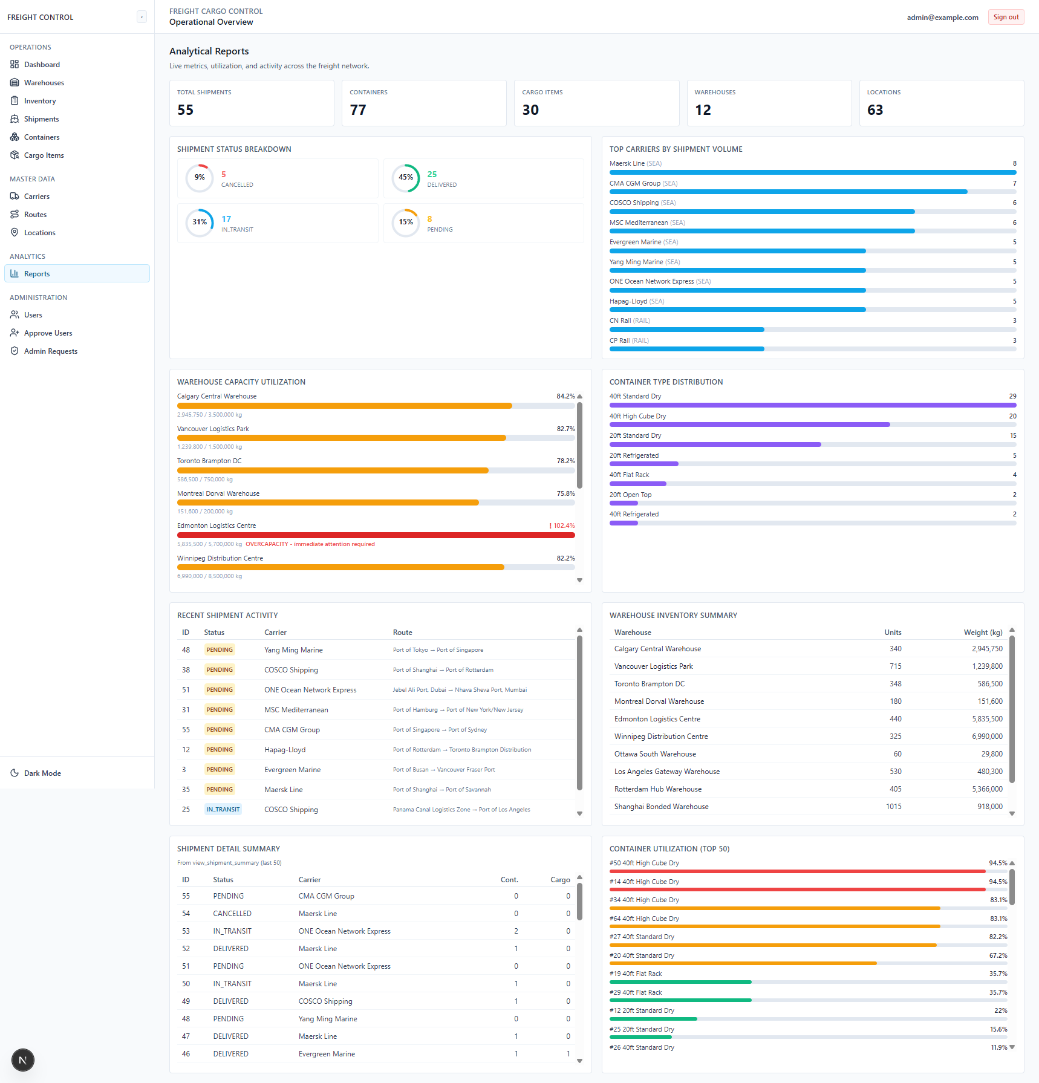

7. Supabase Dashboard and SQL Editor Screenshots
These screenshots are included separately from the application interface because they document the hosted database environment and direct SQL verification workflow rather than the Next.js frontend itself.

7.1 Supabase SQL Tables Overview
This screenshot shows the Supabase dashboard's Table Editor, displaying all the tables in the public schema. This confirms the database structure matches our relational model.
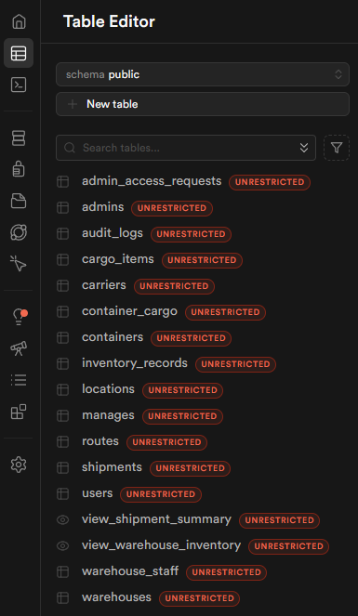

7.2 Supabase SQL Database Overview Diagram
The Supabase dashboard provides an auto-generated database diagram showing all tables and their foreign key relationships. This provides an alternative visualization of the relational model.
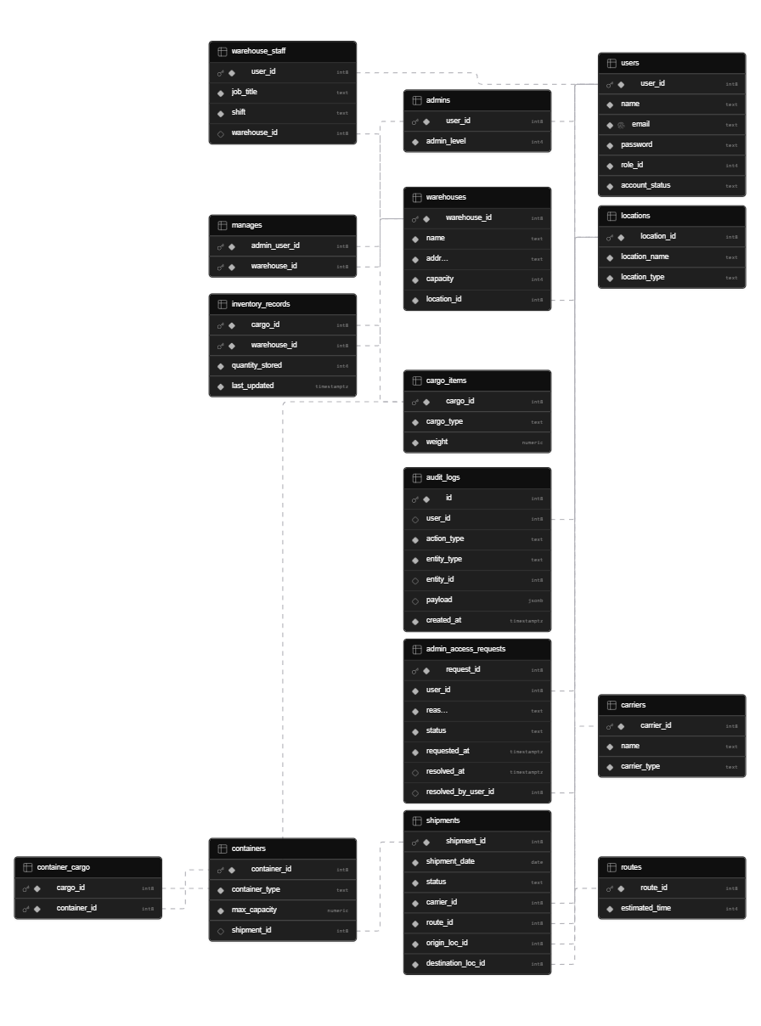

7.3 Supabase Example SQL Query Run
This screenshot demonstrates running an ad-hoc SQL query in the Supabase SQL Editor. This is important because it shows that the database supports direct SQL queries, which means that one can verify data, run custom queries, and test the stored functions directly even without setting up the full application locally.
Test Query:
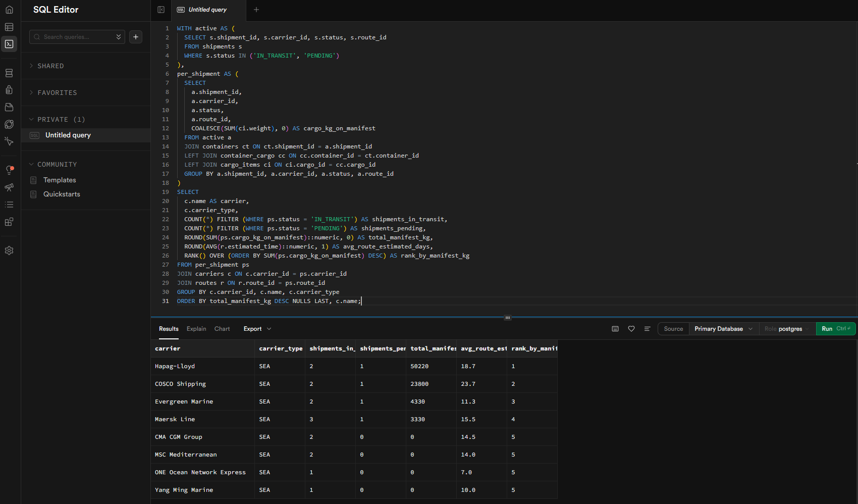

8. User Guide
This section provides a quick guide for using the application. A more detailed guide can be found in README.md.

8.1 Accessing the Application
Option A: Live Demo (Recommended)
- Navigate to https://cpsc-471-inventory-manager.vercel.app
- Log in with any seed account (e.g., admin@example.com / dev-only)
Option B: Local Setup
- Clone the repository: git clone <repo-url>
- Install dependencies: npm install
- Create a Supabase project (see README.md for detailed instructions)
- Create .env.local with your DATABASE_URL, NEXT_PUBLIC_SUPABASE_URL, NEXT_PUBLIC_SUPABASE_ANON_KEY, and DEMOTION_KEY
- Run database setup: npm run db:setup
- Start the dev server: npm run dev
- Open http://localhost:3000

8.2 Admin Workflow
- Log in as admin@example.com (password: dev-only)
- Dashboard shows personalized KPIs for your assigned warehouses
- Warehouses - create, edit, or delete warehouses
- Inventory - view all inventory records, adjust quantities (calls fn_update_inventory)
- Shipments - create new shipments, update status, assign containers
- Containers - manage containers and assign cargo
- Cargo Items - create new cargo types
- Carriers - manage transport companies
- Routes - manage shipping routes
- Locations - manage ports, terminals, warehouses, and distribution centers
- Reports - view aggregated data from view_warehouse_inventory and view_shipment_summary
- Users - create users, assign to warehouses, promote/demote
- Approve Users - approve or reject pending registrations
- Admin Requests - approve or reject staff promotion requests

8.3 Staff Workflow
- Log in as staff1@example.com (password: dev-only)
- Dashboard shows KPIs for your assigned warehouse only
- Inventory - view and adjust inventory for your warehouse
- Shipments, Containers, Cargo Items - view and manage
- Request Admin - submit a promotion request with a reason (max 1000 characters)

8.4 Registration Workflow
- Navigate to /register
- Fill in name, email, and password
- After registration, you are redirected to /pending
- An admin must approve your registration from /admin/approvals/users
- Once approved, you can log in and access the dashboard

8.5 Running SQL Queries Directly
If the application is not accessible or you want to verify database operations directly:
- Log in to the Supabase dashboard (https://supabase.com/dashboard)
- Select the project
- Go to SQL Editor in the left sidebar
- Run any SQL query against the database

9. Summary of Changes from Initial Design
Aspect | Original Plan (Proposal / Progress Reports) | Final Implementation
Total tables | 12 (from EERD) | 15 (added audit_logs, admin_access_requests; plus account_status column)
Authentication | Planned as manual cookie-based | Supabase Auth with JWT cookies and @supabase/ssr
User lifecycle | No status tracking | Full lifecycle: pending_registration -> active/rejected/disabled
Admin promotion | Not planned | Full workflow with admin_access_requests table, staff request form, admin approval UI
Audit logging | Not planned | audit_logs table, fn_audit_log() function, trg_inventory_records_audit trigger
Inventory management | Basic CRUD only | Stored function fn_update_inventory() with UPSERT, negative-quantity guard, and audit logging
Views | 2 planned (basic) | 2 implemented with JOINs and aggregation
Staff-warehouse link | Only through manages | Direct warehouse_id FK on warehouse_staff for simple assignment
Dashboard | Planned as static KPIs | Personalized, warehouse-scoped KPIs with real SQL aggregations
Seed data | Minimal | 63 locations, 12 warehouses, 22 carriers, 55 shipments, 77 containers across 6 continents
Dark mode | Not planned | Full dark/light mode with pure-black background and neutral grey accents
Mobile support | Not planned | Responsive layout with collapsible sidebar drawer
Delete protection | Not planned | All delete operations check for FK references before attempting deletion
Aspect | Original Plan (Proposal / Progress Reports) | Final Implementation
Demotion workflow | Not planned | Admin demotion with DEMOTION_KEY security, self-demotion blocked
Auth user seeding | Not planned | Direct SQL INSERT into auth.users/auth.identities with bcrypt hashing via pgcrypto

10. Conclusion
This project demonstrates a complete, databases-first approach to building a freight cargo management system. Starting from an Enhanced Entity-Relationship Diagram, we applied the standard EERD-to-relational-model conversion algorithm to produce a normalized PostgreSQL schema. We then implemented the schema with full constraint enforcement, added views for reporting, stored functions for business logic, and triggers for automatic audit logging. The web interface provides role-based access for two user types, personalized dashboards, and full CRUD operations on all entities. The system includes realistic seed data modeling a global freight network, making it suitable for demonstration and evaluation. All SQL is visible and parameterized, and the database can be queried directly through the Supabase SQL Editor even without the web application running.

